**CONCLUSIONES DEL “A PROOF OF STAKE DESIGN PHILOSOPHY”**

Lo más interesante del artículo es el penúltimo párrafo que dice lo siguiente:

* “**Consensus protocols that work as-fast-as-possible have risks and should be approached very carefully if at all**, because if the possibility to be very fast is tied to incentives to do so, the combination will reward very high and systemic-risk-inducing levels of **network-level centralization**(eg. all validators running from the same hosting provider). Consensus protocols that don’t care too much how fast a validator sends a message, as long as they do so within some acceptably long time interval (eg. 4–8 seconds, as we empirically know that latency in ethereum is usually ~500ms-1s) do not have these concerns. A possible middle ground is creating protocols that can work very quickly, but where mechanics similar to Ethereum’s uncle mechanism ensure that the marginal reward for a node increasing its degree of network connectivity beyond some easily attainable point is fairly low.

“

Sugiere que si el protocolo es capaz de ir muy rápido, puede que se induzca una centralización a nivel de red. Esto podría ser así en el caso de Proof of Traceability, sin embargo, tengo en mente la manera de solucionarlo: incluir en el algoritmo la idea del algoritmo Proportional Fair utilizado en las redes LTE:

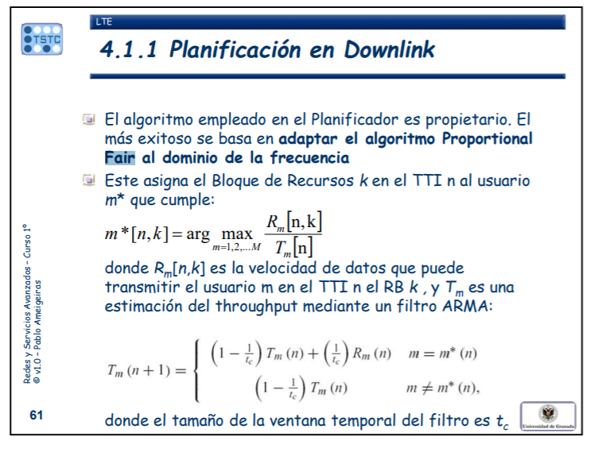

También habla de la latencia de la red Ethereum, sin embargo creo que no hay estudios al respecto.